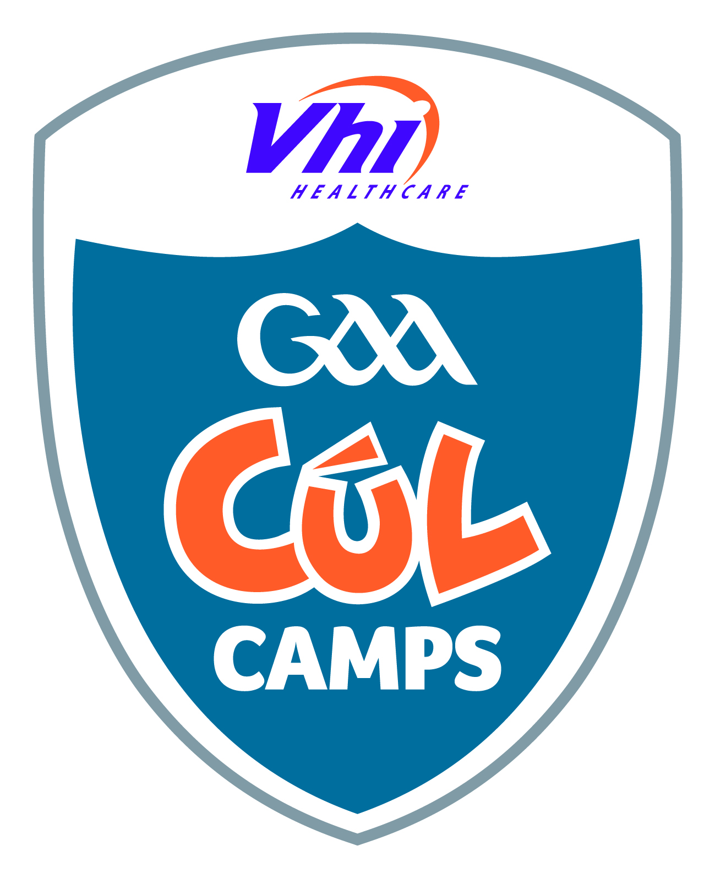

Summer Job Application Form

Position: Cavan GAA – Summer Job
1. Name in full (Block Letters)

2. Postal Address (Block Letters)

3. Telephone No. Home
Mobile
E-Mail Address
4. Do you hold a full-unendorsed Irish driving licence? Yes No
5. Have you completed the New GAA Foundation Course? Yes No
5. Please provide a brief paragraph on Why Cavan GAA should employ you this summer!

6. Coaching Qualifications (if any)
Please state any relevant Coaching Qualifications which you may have: (Please include Date of course, Venue and supply a copy of any Certificates along with this application)

7. Coaching Experience
Please provide details of any necessary Coaching Experience which you may experienced over the past 1-3 years:

10. References:
Give name and address of one responsible persons to whom you are
well known, but not related. Cavan GAA will assume permission to contact
referees unless the Applicant has stated otherwise.
(1)
Name

Address

Occupation

Signature of Applicant
Date
When you have signed and completed the application form, please post back to
Cavan GAA – Summer Job,

Coaching & Games Development,
Kingspan Breffni Park,
Cavan.

Closing date: Friday 20th May 2011

