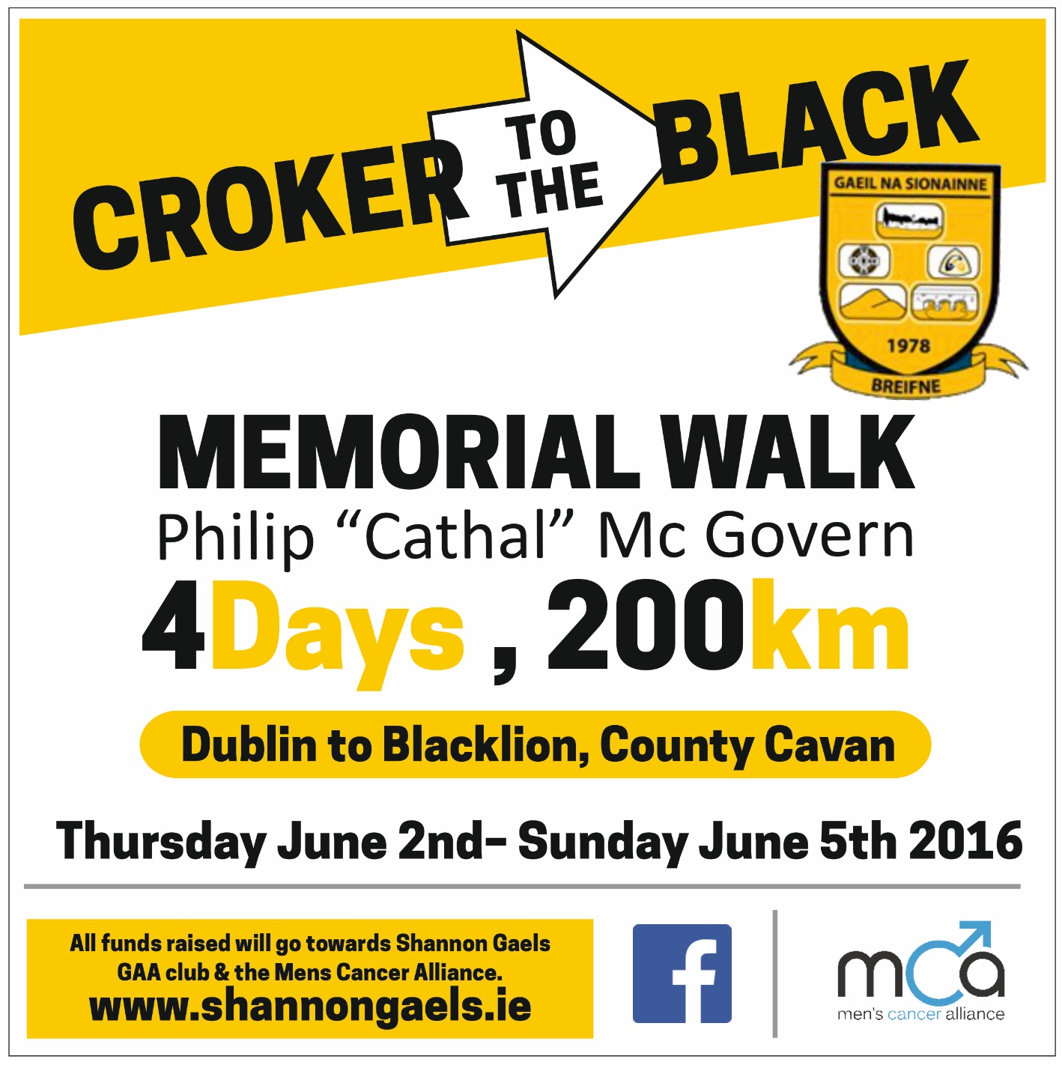
Day 1 – Thursday 2nd June
 | Times
Croke Park | 8:00am
Phoenix Park | 8:50am
Castleknock | 9:55am
Blanchardstown | 10:40am
Clonee | 11:35am
Dunshaughlin | 2:40pm
Navan | 7:30pm

