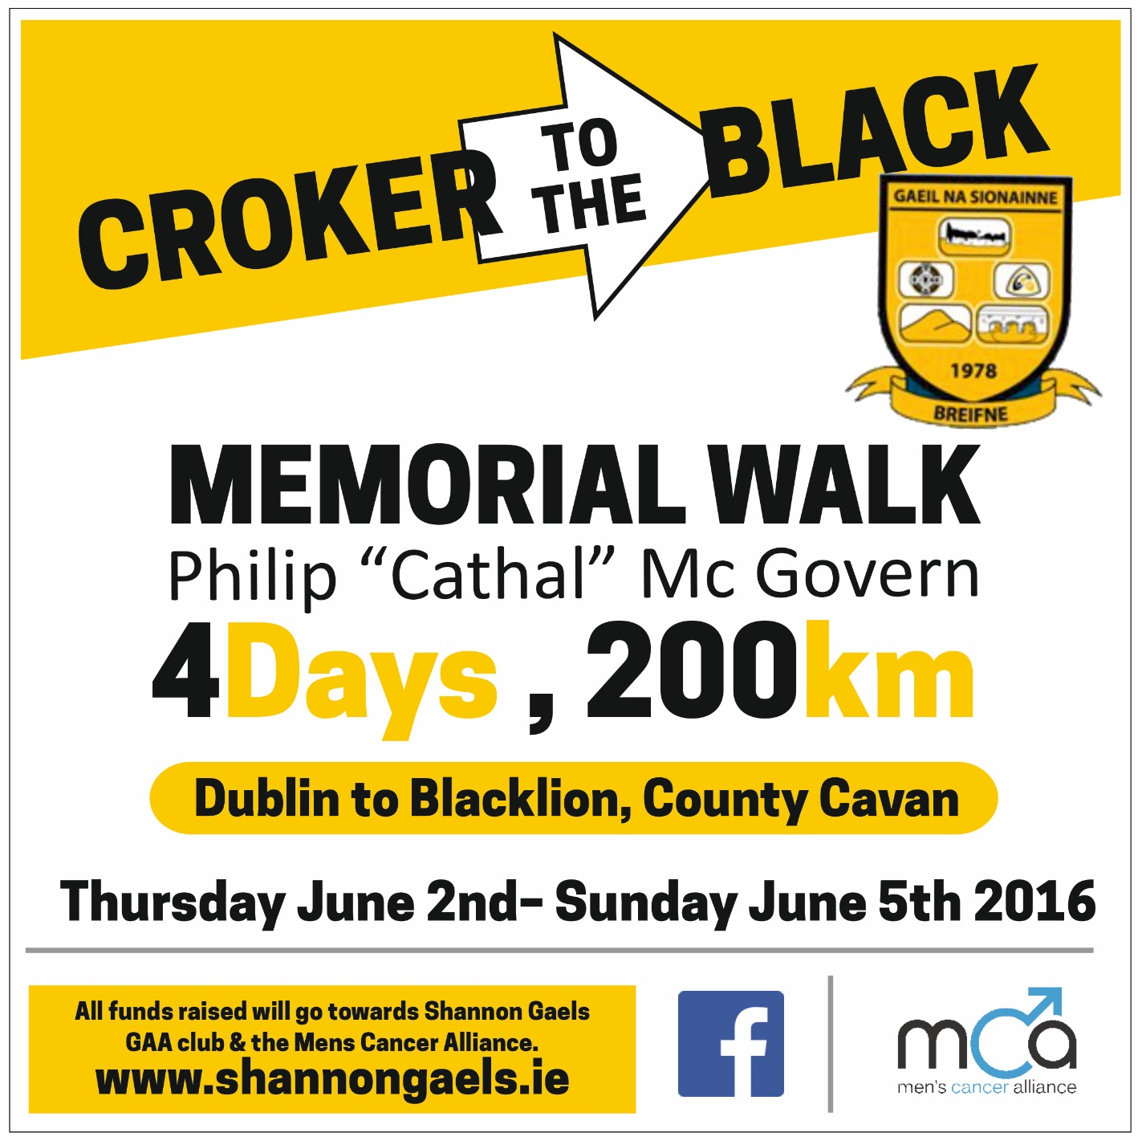
Day 2 – Friday 3rd June
 | Times
Navan | 8:00am
Kells | 11:05am
Carnacross | 12:40pm
Virginia | 3:10pm
The Lavey Inn | 7:55pm

