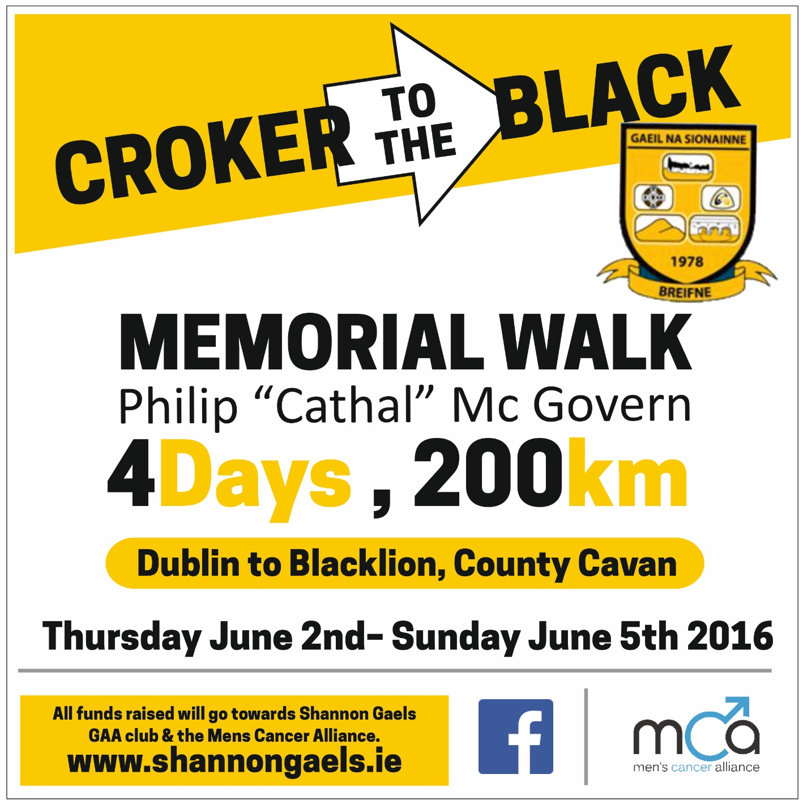
Day 3 – Saturday 4th June
 | Times
The Lavey Inn | 8:00am
Cavan- Breffni Park | 10:05am
Butlersbridge | 12:00pm
Belturbet | 1:40pm
Ballyconnell | 5:15pm
Bawnboy | 6:30pm
Swanlinbar | 8:30pm

