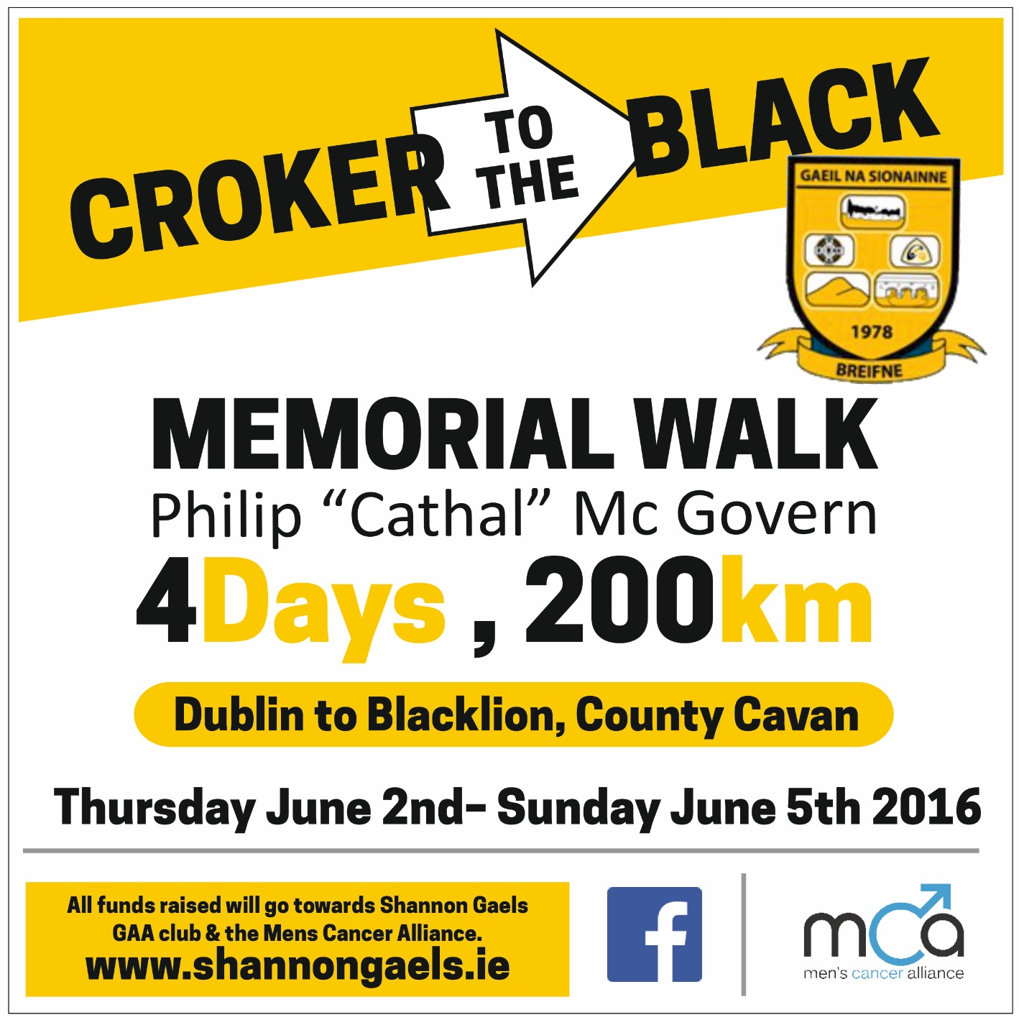Day 4 - Sunday 5th June

|  |  |
| --- | --- |
|  | **Times** |
| **Swanlinbar** | 9:00am |
| **Glangevlin** | 12:15pm |
| **Dowra** | 3:00pm |
| **Killinagh Church Car Park** | 6:10pm |
| **Blacklion** | 6:40pm |