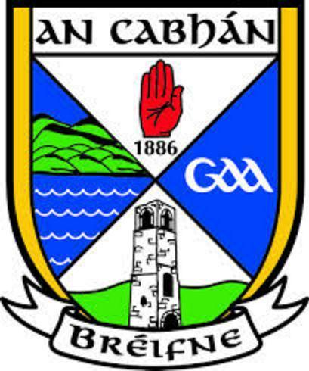
Championship Rd 1 – Thursday, July 27th to Sunday, July 30th

Thursday, July 27th
Cully’s Craft Bakery Junior Championship
In Mullagh @ 8pm
Munterconnaught vs. Maghera

Friday, July 28th
Hotel Kilmore Intermediate Championship
In Butlersbridge @ 8pm
Drumlane vs. Redhills

In Mullahoran @ 8pm
Killeshandra vs. Ballyhaise

Hotel Kilmore Senior Championship
In Kingscourt at 8pm
Ramor Utd vs. Cuchulainns

In Kingspan Breffni @ 8pm
Cavan Gaels vs. Lacken

Saturday, July 29th
Cully’s Craft Bakery Junior Championship
In Drumlane @ 7pm
Templeport vs. Drung

In Stradone @ 7pm
Kildallon vs. Kill

Hotel Kilmore Intermediate Championship
In Ballinagh @ 7pm
Ballymachugh vs. Drumalee

In Killygarry @ 7pm
Killinkere vs. Belturbet

Hotel Kilmore Senior Championship
In Kingspan Breffni @ 6.30pm
Lavey vs. Cootehill

In Kingspan Breffni @ 8pm
Castlerahan vs. Arva

Sunday, July 30th
Cully’s Craft Bakery Junior Championship
In Ballyhaise @ 2pm
Swanlinbar vs. Drumgoon

In Lavey @ 5pm
Mountnugent vs. Knockbride

In Swanlinbar at 7pm
Shannon Gaels vs. Corlough

Hotel Kilmore Intermediate Championship
In Virginia @ 2pm
Denn vs. Bailieborough

In Virginia @ 3.30pm
Shercock vs. Cornafean
In Drumalee @ 5pm
Butlersbridge vs. Laragh Utd

Hotel Kilmore Senior Championship
In Kingspan Breffni @ 2pm
Killygarry vs. Gowna

In Kingspan Breffni @ 3.30pm
Kingscourt vs. Mullahoran

In Kingspan Breffni @ 7pm
Crosserlough vs. Ballinagh

